  
  
  
  
CS 319 - Object-Oriented Software Engineering  
System Design Report  
  
  
Animal Uprising  
Group 3-A  
Bora Ecer

Ata Gün Öğün

Albjon Gjuzi

Tanay Akgül

1. Introduction 4

1.1 Purpose of the System 4

1.2 Design Goals 4

1.2.1 Efficiency 4

1.2.2 Portability 4

1.2.3 Reliability 5

1.2.4 Extensibility 5

1.2.5 Tradeoffs 5

1.2.6 Definitions, acronyms and abbreviations: 6

1.2.7 References 6

2. Software Architecture 7

2.1 Subsystem Decomposition 7

2.2 Hardware/Software Mapping 9

2.3 Persistent Data Management 9

2.4 Access Control and Security 9

2.5 Boundary Conditions 9

3. Subsystem Services 11

3.1 Game Control Subsystem 11

3.1.1 GameManager Class 12

3.1.2 ObjectManager Class 14

3.1.3 InputManager Class 15

3.1.4 SoundManager Class 16

3.1.5 ImageManager Class 16

3.1.6 States Class 16

3.1.7 GameState Class 17

3.1.8 PauseState Class 17

3.1.9 MenuState Class 17

3.1.10 ShopState Class 17

3.1.11 SettingsState Class 17

3.2 UI Management Subsystem 18

3.2.1 GameEngine Class 18

3.3.2 Menu Class 19

3.2.3 ShopMenu Class 20

3.2.4 PauseMenu Class 21

3.2.5 MainMenu Class 21

3.3 Game Model Subsystem 22

3.3.1 GameObject Class 23

3.3.2 CharacterObject Class 24

3.3.3 MinionObject Class 24

3.3.4 Minion Classes and Interfaces 25

3.3.5 HeroObject Class 26

3.3.6 CastleObject Class 26

4. Low-Level Design 26

4.1 Object Design Trade-offs 26

4.2 Final Object Design 27

4.3 Packages 28

4.3.1 java.util 28

4.3.2 java.awt 28

4.3.3 java.awt.event 28

4.4 Class Interfaces 28

4.4.1 ActionListener 28

4.4.2 MouseListener 28

4.4.3 KeyListener 28

4.4.4 MouseListener 28

4.4.5 Runnable 28

5. Glossary & References 28

# **Introduction**

## **Purpose of the System**

Animal Uprising is a 2D strategy/adventure game which aims to provide a well-designed and enjoyable gameplay to entertain the players. The gameplay experience starts with an easy level which will work as a tutorial for the players, so that they can learn the game. However, in order to provide more satisfaction and pleasure the next levels of the game is designed to be more challenging, so that the game will have the player’s attention, and increase the urge to play the game.

## **1.2** **Design Goals**

### **1.2.1 Efficiency**

The main design goal of the system is efficiency, to achieve that, the system must be able to work in high performance. Since, a smooth gameplay is one of the most important feature which increases the player’s urge to play the game, we are going to minimize the memory usage and the CPU usage. In order to achieve that, first, we are going to implement the code in the most efficient way possible. Also, we are going to design the system so that the workload of the objects is going to be nearly balanced.

### **1.2.2 Portability**

Since portability is an important feature for a software to have various users from different platforms, we have decided to implement the game in Java, since it provides platform independent software which will make our system portable through various platforms.

### **1.2.3 Reliability**

Our system will be reliable in terms of being consistent with the boundary conditions. The system should not respond with any unexpected results -like bugs, crashes- which are not specified in the boundary conditions. In order to provide that, we are going to test the system in all possible ways during and after the development stage. Also, the boundary conditions will be selected carefully and with caution so that there won’t be a case with which puts the system in an unexpected situation. This will provide the system to foresee the possible fatal failures which will be dealt with.

### **1.2.4 Extensibility**

In order to keep the interest of the players of Animal Uprising, the game requires to have new features and functionalities. For that the design of the game must be suitable to add further improvements and additions to the current system. In order to achieve this, object oriented architecture of our game must be designed in a way that each object should be able to operate with few dependencies. So that the modifications and further additions won’t cause any bugs or crashes.

### **1.2.5 Tradeoffs**

* **Functionality vs Usability**

Our game focuses on usability more than functionality since our main goal is to entertain the users with a basic game. So, instead of developing a complex system, focused on developing a basic system which is easier to use.

* **Efficiency vs Portability:**

Portability is very important for a game to reach wider range of users. Since we use Java, which offers a platform independent program, we satisfy the portability feature, however, since java is less efficient compared to the other languages, in this process we sacrifice the efficiency.

* **Cost vs Reusability:**

We did not focus on reusability while designing our system because we are not planning to use the existing classes of our game in different projects. Therefore, the classes are designed to do their task only for this system which will make our system less complex and prioritizing the cost.

### **1.2.6 Definitions, acronyms and abbreviations:**

JDK: [1] Java Development Kit

MVC: [2] Model-View-Controller

### **1.2.7 References**

[1]: <http://www.oracle.com/technetwork/java/javase/overview/index.html>

[2]: Object-Oriented Software Engineering, Using UML, Patterns, and Java, 3rd Edition*, by Bernd Bruegge and Allen H. Dutoit, Prentice-Hall, 2010.*

# **2. Software Architecture**

## **2.1 Subsystem Decomposition**

In this section, we will decompose the overall system into three different subsystems in order to use Model-View-Controller architectural style on our system. By doing that, we would like to accomplish creating a maintainable, efficient and flexible system.

Figure-1 is showing how the system is decomposed into three subsystems which are User-Interface Management, Game Control and Game Models.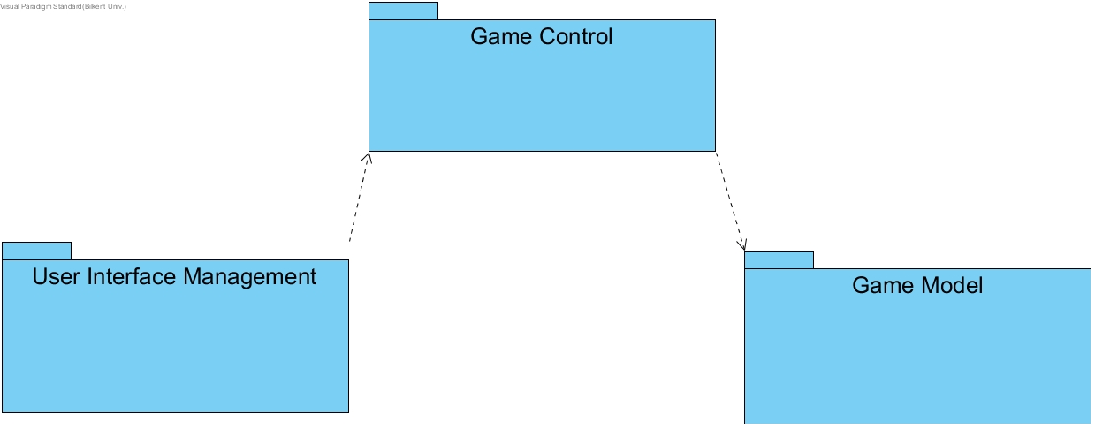

Figure-1 (System Decomposition)

All three systems are working on different tasks, and they communicate as given in the figure. User Interface Management includes the Menu package, and the Game Engine class, which will be responsible the construction of the game screen, according to the inputs from GameManager class which is in the Game Control Subsystem. Game Manager class will be responsible for handling the inputs, and making the decisions regarding to them, these decisions includes manipulating the user interface and the objects. Therefore, the GameManager class will be the façade class for the entire system.

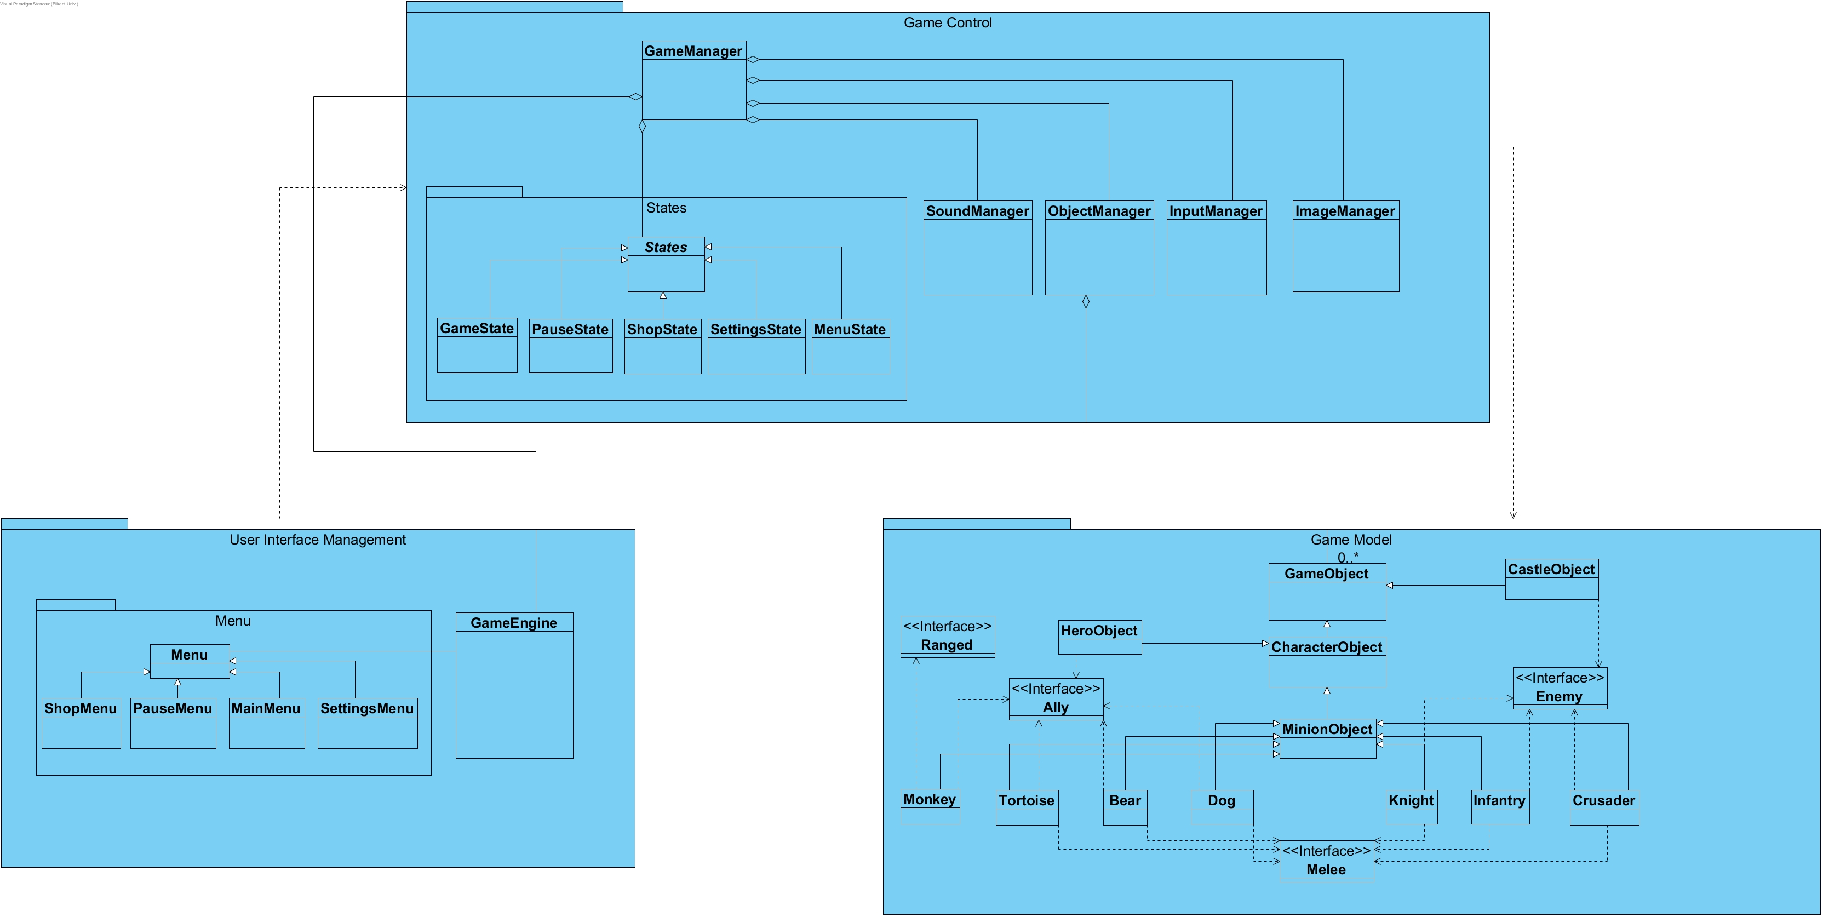

Figure-2 (Detailed System Decomposition)

Game Models Subsystem which has the game objects and their attributes. Because of this, the Game Control Subsystem, mainly ObjectManager class will be able to manipulate them.

## **2.2 Hardware/Software Mapping**

Since our game will be implemented in Java, we will use the JDK 8. As for the hardware requirements, a keyboard and a mouse will be required so that the player can interact with the game. Since we are not planning to implement a complex system, a basic computer should be enough to run our game.

## **2.3 Persistent Data Management**

Our system does not require a complex database for managing the data, therefore we are planning to store the game data in the client disk. So, whenever the system executes, we are going to load the files which are required for the system, to memory. Also, we are planning to store the images (gifs, and etc.) also the sound effects of the objects and the background music of the game.

## **2.4 Access Control and Security**

Since the game does not require any network connection, therefore we will not implement any user authentication system. For software control, the GameControl subsystem will be able to access the files in order to assure the security of the data required for the game.

## **2.5 Boundary Conditions**

**Initialization:** The executable file of the game will be .jar file so it will not require an install. At startup time, the GameControl subsystem will be registered. The GameControl will access the data which is required for the user interface, and the sound effects.

**Termination:** The game can only be terminated from the main and pause menus, which will have a “Quit Game” button, and it will require user input. When the game is terminated, the Game Control subsystem will automatically inform the other subsystems to terminate as well.

**Failure:** During a communication failure, the system will check the files or the data required are corrupted or not, if it is the system will erase the contents of these files.

# **Subsystem Services**

## 3.1 Game Control Subsystem

### 3.1.1 GameManager Class

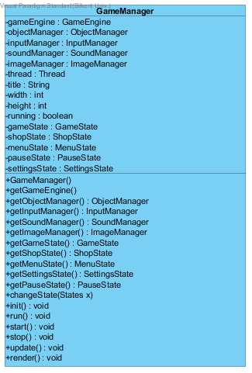

**Attributes:**

**private gameEngine:** This attribute will be an instance of GameEngine class which is definitely needed to make the necessary updates on the screen.

**private objectManager:** This attribute will be an instance of ObjectManager class in order to keep and update every game object that will be displayed.

**private inputManager:** This attribute will be an instance of InputManager class that is needed to make the user play the game, otherwise he would not move and click.

**private soundManager:** This attribute will be an instance of SoundManger class that is needed to control the sound effects during the execution time of the program.

**private imageManager:** imageManager is an instance of ImageManager class, which is used to load the images that will be rendered into the screen.

**private thread:** this attribute provides a concurrent execution, which is required for the game loop.

**private title:** a string variable to keep and pass the title to gameEngine.

**private width:** an integer variable to keep the width of the game screen and pass it to gameEngine.

**private height:** an integer variable to keep the height of the game screen and pass it to gameEngine.

**private running:** a Boolean attribute to check whether the game loop is running or not.

**private gameState:** an instance of GameState whose methods will be used while the player plays the game.

**private menuState:** an instance of menuState whose methods will be used while the player is using the main menu.

**private shopState:** an instance of ShopState whose methods will be used while the player is using the shop.

**private pauseState:** an instance of PauseState whose methods will be used when the program needs to render the pause menu.

**Constructor:**

**Public GameManager():** initializes instances of GameManager.

**Methods:**

**Public GameEngine getGameEngine():** getGameEngine method will get the GameEngine object needed for the app to function.

**Public ObjectManager getObjectManager():**getObjectManager method will be used to obtain the ObjectManager that controls all the objects in the game.

**Public InputManager getInputManager():** getInputManager method will be used to get the input controls that the user can use to play the game.

**Public ImageManager getImageManager():** getImageManager method will be used to get the images from the imageManager instance that the user can use to play the game.

**Public SoundManager getSoundManager():** getSoundManager method will be used to obtain the sound settings.

**Public void init():** It initializes the manager objects, gameEngine object, states objects and finally sets the currentState, which is the menuState.

**Public void run():** run method is an unimplemented method provided by Runnable interface. Which is automatically called when the start() method is used. Run() method first calls init() method to initiate the objects required, then it starts the game loop, which does not end until the game ends. In every iteration of the game loop, it calls update() and render() methods. Once the game ends, the execution of the run method ends with the call of the stop() method.

**Public void start():** start() method

**Public void stop():**

**Public void render():**

**Public void setGameState():**

### 3.1.2 ObjectManager Class

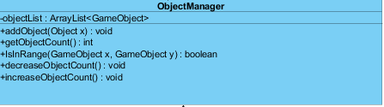

ObjectManager is also one of the important classes of our project since every object that will be displayed throughout the whole execution time of the program will be controlled and stored the ObjectList this class will have. It will basically function as an ArrayList of GameObject’s.

***Constructor:***

**public ObjectManager():** It initializes instances of **ObjectManager** object.

***Attributes*:**

**private objectList:** This attribute will be an ArrayList of GameObjects. GameObject is everything that will be displayed in the screen, the castle, the enemies, the hero or its allies.

***Methods*:**

**public void addObject(GameObject x):** This method will be used to add gameObjects to the ArrayList mentioned above.

**public void update()**: This method is just going to update the list every moment and it is going to update every GameObject.

**public void updateLocationMap():** Here we will update every GameObject’s location on the map of the game, that means the frame of java application, because everything is simply a bunch of paintings that makes the view look like a game.

**public boolean isInRange(GameObject x,y):** The method will be used to check the location of each object. This Boolean method will be helpful for the update methods above.

### 3.1.3 InputManager Class

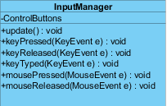

***Contsructor:***

**public InputManager():** It initializes instances of **InputManager** object.

***Attributes*:**

**private ControlButtons:** This arrayList is enough to store the buttons that the player can use during his game. The buttons will then be provide to the GameManager class.

***Methods*:**

**public ArrayList getButtons():** This method will be accessed from the GameManager class we previously mentioned in order to get the buttons.

### 3.1.4 SoundManager Class

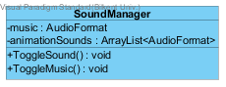

***Methods:***

**public void toggleSound():** This method enables the sounds of the game.

**public void toggleMusic():** This method sets the music of the game.

### 3.1.5 ImageManager Class

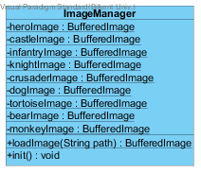

### 3.1.6 States Class

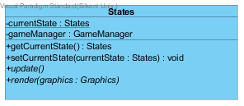

### 3.1.7 GameState Class

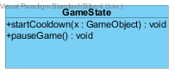

### 3.1.8 PauseState Class

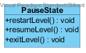

### 3.1.9 MenuState Class

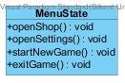

### 3.1.10 ShopState Class

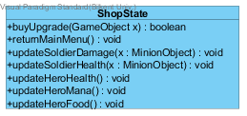

### 3.1.11 SettingsState Class

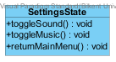

## 3.2 UI Management Subsystem

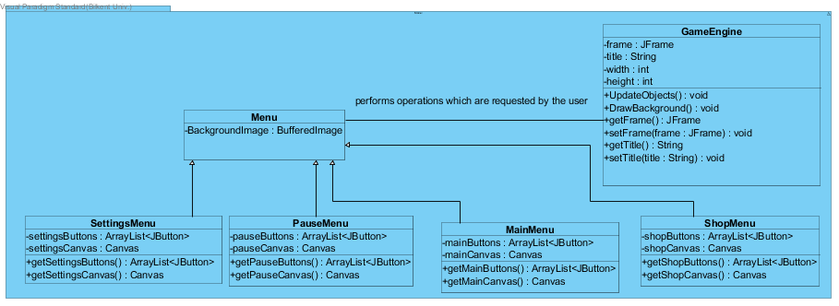

### 3.2.1 GameEngine Class

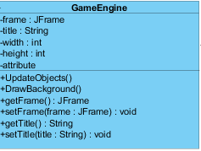

* Every game needs its engine and so does ours. This class will provide everything needed to play the game in the correct manner and it will connect the other main subclasses. This class is updates GameManager class which then takes care of the other things.

***Constructor:***

**public GameEngine():** It initializes instances of **GameEngine** object.

* There will be no attributes in this class, but maybe we can add some if we need them in the future.

***Methods*:**

**public void UpdateObjects():** This method will update every game view in every second depending on the user choices or the automatic movements that will take place during the execution of the program.

**public void DrawBackground()**: This method is just going to draw the background based on what stage the game is. By that I mean, if the user is currently playing, is in the main menu, is in the pause menu or is restarting the game.

### Menu Class



***Attributes:***

**private bufferedImage backgroundImage:** This attribute sets background image of the menu.

***Constructors:***

**public Menu:** Initializes background image.

### 3.2.3 ShopMenu Class

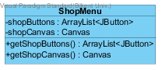

***Attributes:***

**private ArrayList<ItemList> itemList:** This attribute holds the items the player will buy.

**private ArrayList<UpgradeList> upgradeList:** This attribute holds the upgrade objects the player will shop.

***Constructors:***

**public ShopMenu:** Initializes item list and upgrade list.

***Methods:***

**public boolean buy() :** returns true if the player buys item.

**public boolean upgrade(Game object x):** returns true if the player upgrades his/her character.

### 3.2.4 PauseMenu Class

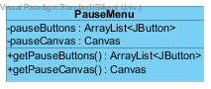

***Methods:***

**public void restartLevel():** This method restarts the level of the game.

**public void resumeLevel():** This method resumes the level.

**public void exitLevel():** This method ends the run of the level.

**public void settings():** This method applies the given settings to system.

### 3.2.5 MainMenu Class

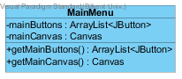

***Methods:***

**public void exitGame():** This method ends the run of application.

**public void startNewGame():** This methods starts a new game by resetting game datas.

**public void loadGame():** This method loads the game which the player previously played.

### 3.2.6 SettingsMenu Class

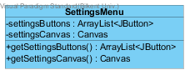

## 3.3 Game Model Subsystem

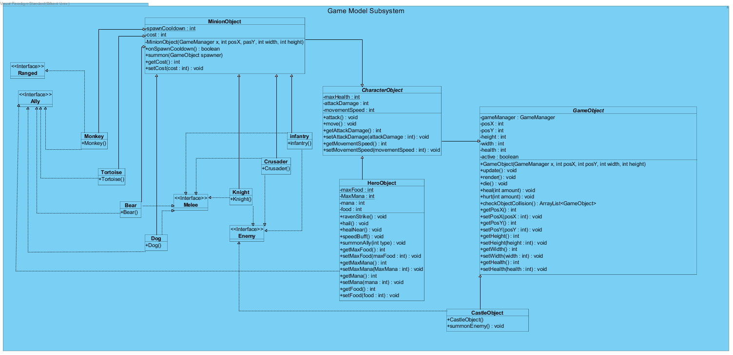

“Game Model Subsystem” describes the entities that are used while the game is running. It has describes many crucial objects including all the enemy and ally soldiers, the hero itself and the enemy castle. It also has interfaces such as “**Ally**”, “**Enemy**”, “**Melee**” and “**Ranged**”.

### 3.3.1 GameObject Class

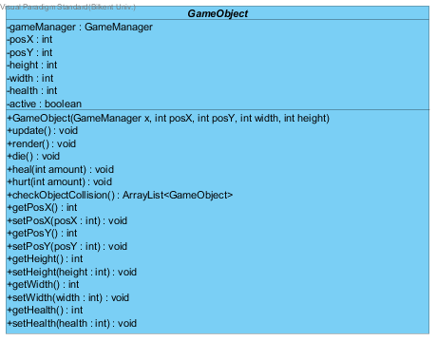

“**GameObject**” is an abstract class that is the parent of all game objects including HeroObject, all Soldier objects and **CastleObject**. This class has attributes and methods that all entities should have such as position information declared as “**posX**” and “**posY**”, image of the entity declared as “objectImage”, width and height of the object and so on. Operations such as “**update**()”, “**render**()”, “**die**()” and “**hurt**()” are defined as abstract operations since different types of objects might need to act differently to these operations. The “**render**()” and “**update**()” methods are periodically called by the **ObjectManager** on active **GameObjects**.

### 3.3.2 CharacterObject Class

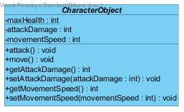

“**CharacterObject**” is also an abstract class that is the parent of all character objects like enemy and ally soldiers. The “**attack**()” and “**move**()” operations are defined as abstract operations since every character can have different attack and move values/patterns.

### 3.3.3 MinionObject Class

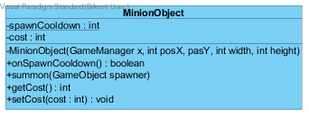

“**MinionObject Class**” is yet another abstract class that has the common attributes of all the soldier type objects. They have a private constructor and they are intended to be constructed only by the “**summon**()” operation given the conditions are met.

### 3.3.4 Minion Classes and Interfaces

Classes like “**Monkey**”, “**Tortoise**”, “**Bear**” and “**Infantry**” are all child classes of the “**Minion**” abstract class. Their hostility is indicated using the “**Ally**” or “**Enemy**” interfaces. And their attack type is indicated by the “**Melee**” and “**Ranged**” interfaces. Note that Tortoise class implements neither the “**Ranged**” or the “**Melee**” interface, since it is a defensive soldier that does not attack.

### 3.3.5 HeroObject Class

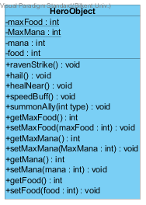

“**HeroObject**” class defines the character which the player controls. The “**coins**”, “**mana**” and “**food**” values are also held in this object.“**ravenStrike**()”, “**hail**()” , “**healNear**()” and “**speedBuff**()” methods all correspond to skills the player can cast using mana. The player can also summon an ally soldier using food, thanks to the “**summonAlly**()” method.

### 3.3.6 CastleObject Class



# Low-Level Design

## 4.1 Object Design Trade-offs

## 4.2 Final Object Design

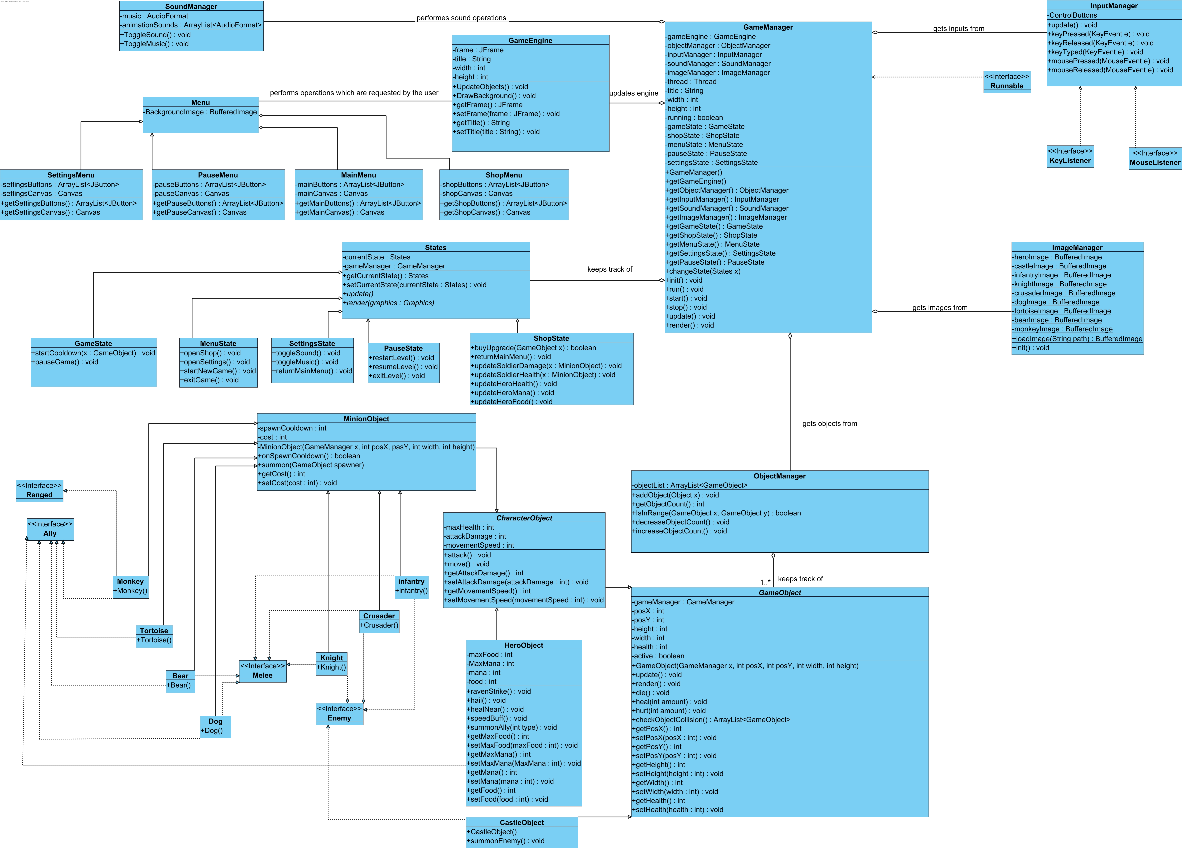

## 4.3 Packages

### 4.3.1 java.util

### 4.3.2 java.awt

### 4.3.3 java.awt.event

## 4.4 Class Interfaces

### 4.4.1 ActionListener

### 4.4.2 MouseListener

### 4.4.3 KeyListener

### 4.4.4 MouseListener

### 4.4.5 Runnable

# 5. Glossary & References